**Our Team**

**Here at Geotech Drilling & Construction we pride ourselves on our extensive experience and our strong TEAM focus. Our staff is comprised of some of the best, most experienced professionals in the industry that aim to deliver the highest quality product possible.**

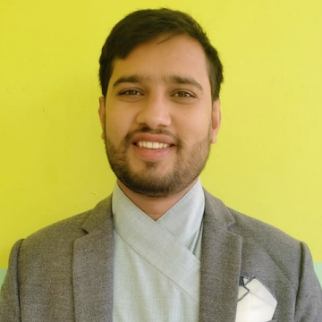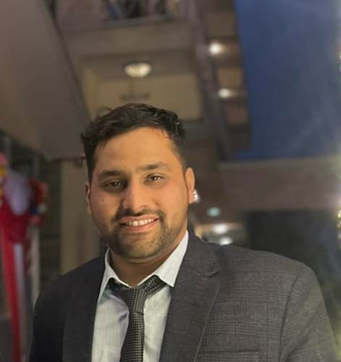

**Mr. Kahgendra Pokhrel Er. Sundar Aryal**

**Managing Director Operation Director**

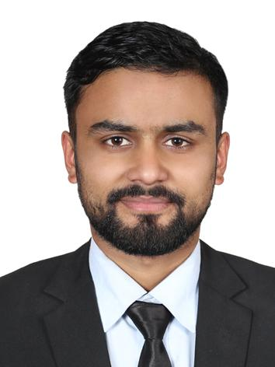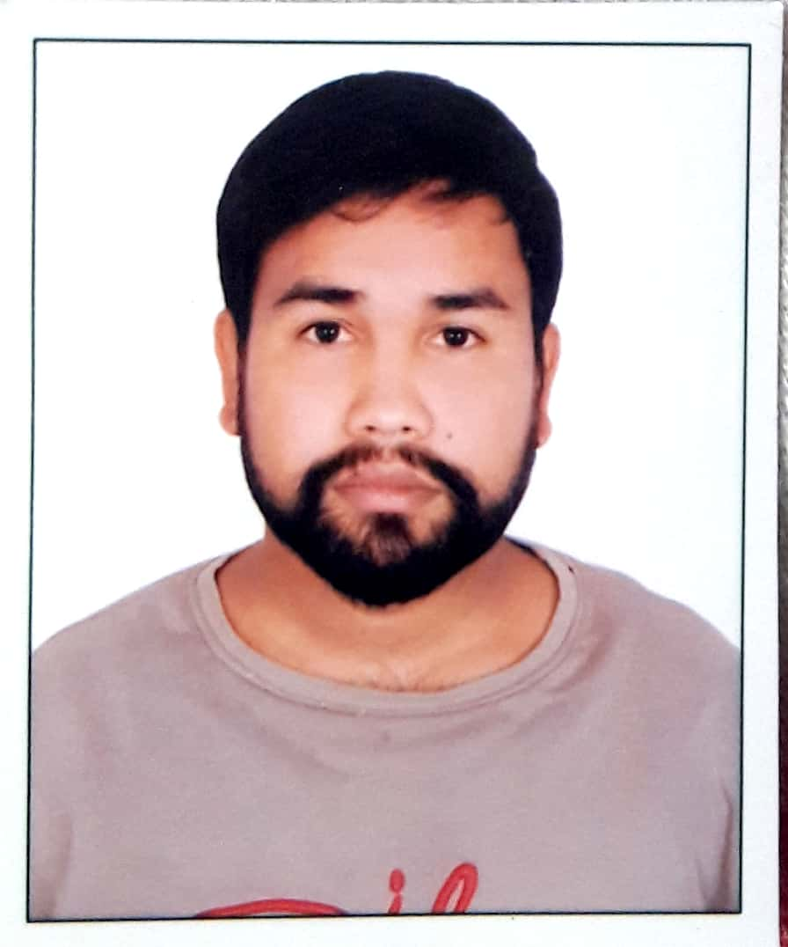

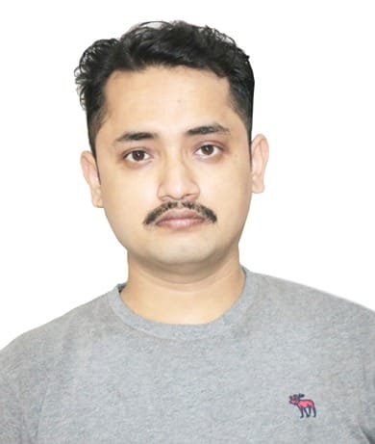

Keshab Thapa Lokraj Phuyel Sabin Pokhrel

General Manager **Construction Manager Leagal Advisor**